**TASK: Launch a t2.micro instance in Mumbai region where ssh can be done**

**only from your IP address with docker and docker-compose installed in it.**

1: Launching Instance 1 (t2.micro) and creating the security group to provide permission to access the instances from my IP address: (AWS-Mumbai Region)

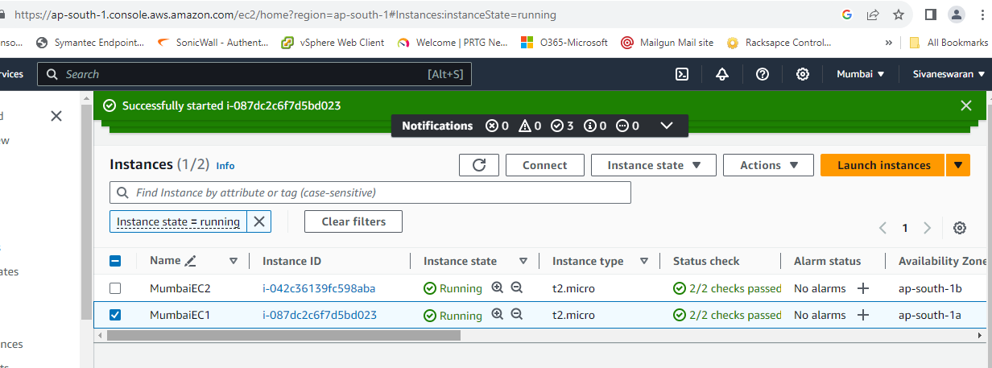

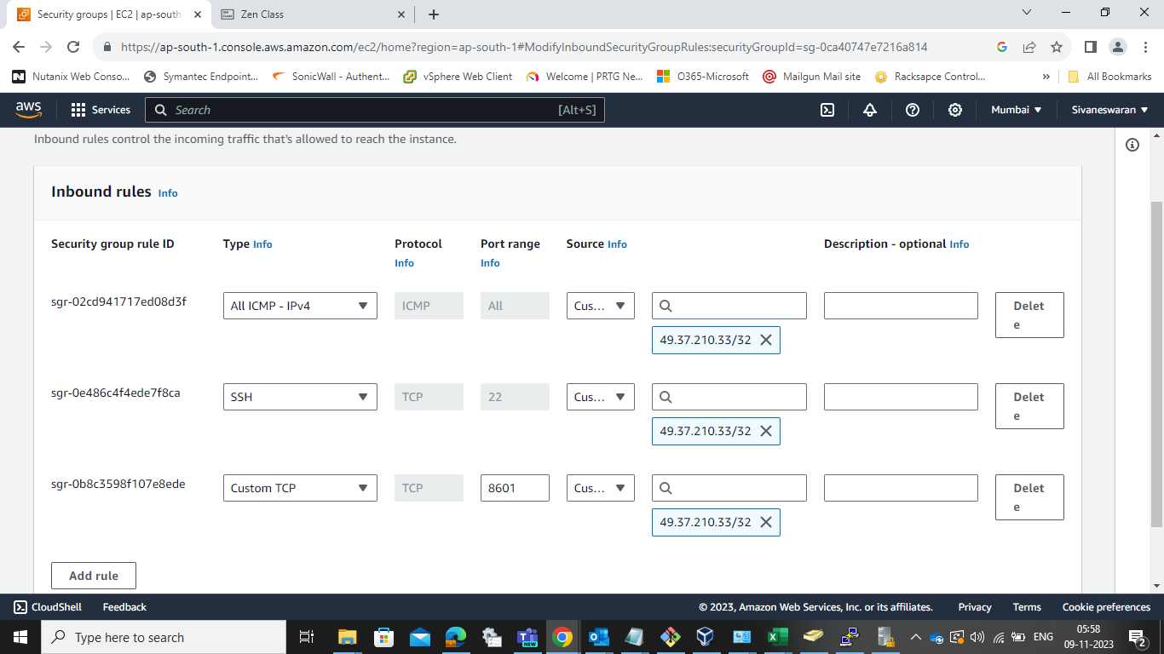

2: Connected the AWS instances from my IP address



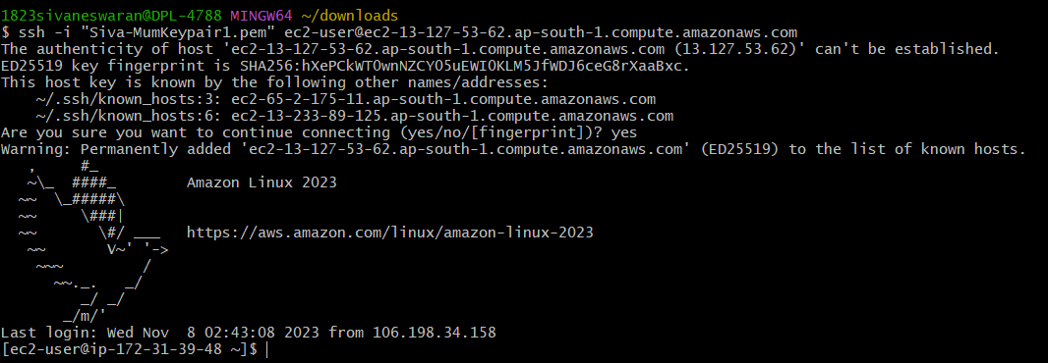

3) Installing the docker and docker compose in AWS-Mumbai-EC2-1

A: Installing docker

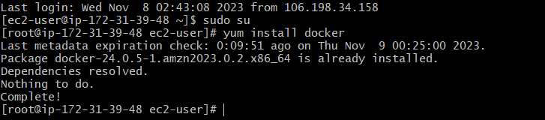

Checking the version of docker installed



b) Installing the docker-compose

curl -SL https://github.com/docker/compose/releases/download/v2.23.0/

docker-compose-linux-x86_64 -o /usr/local/bin/docker-compose



Linking the path to different path



Providing the RWX permission for root user to the path

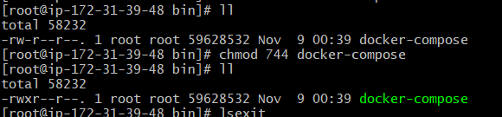



2) Launching Instance 2 and creating the security group to provide permission to access the instances from my IP address: (AWS-Mumbai Region)

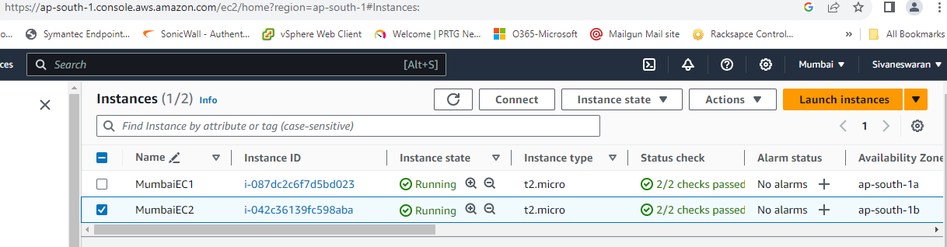

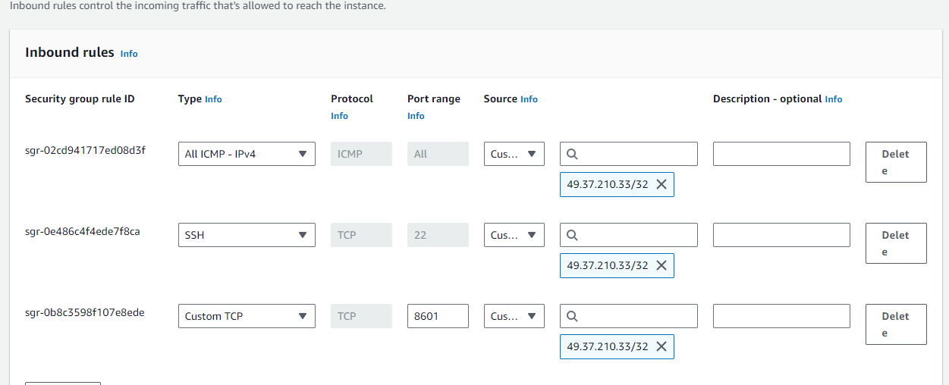

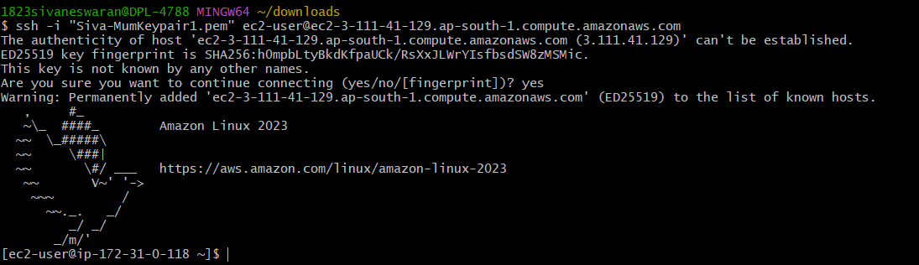

Installing the Docker and Dcoker-Compose (AWS-Mumbai-EC2)

A: Installing Docker

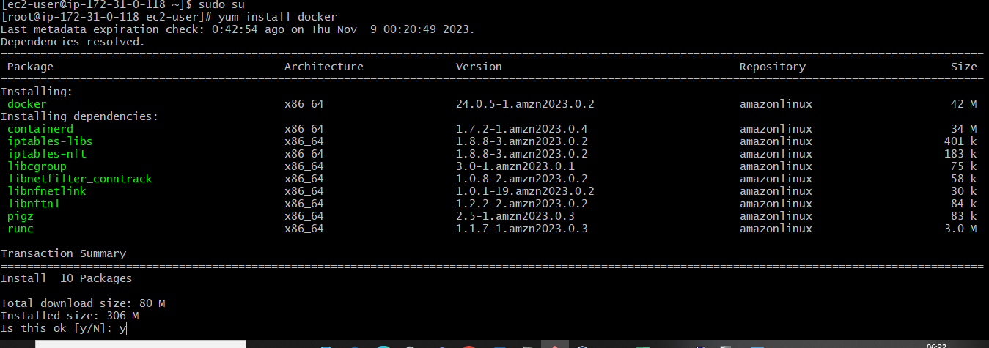

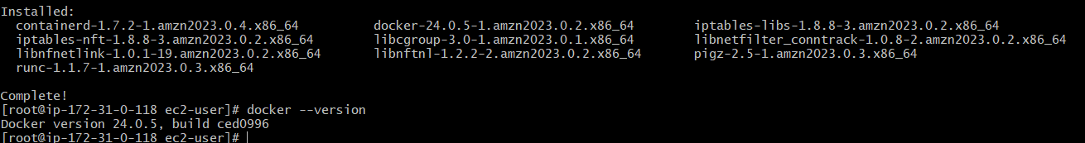

B: Installing Docker-Compose



Checking the version

